Project Synopsis

On

**FACE RECOGNITION**

Submitted By:

Piyush Kakkar

B.Tech.(Information Tecnology)

Enr. No: 02996403114

2017-2018

**Objective**

To design a system which is capable of detecting faces by their names and identifying multiple faces in real time. The software system will use face detection algorithms to accurately identify and recognize faces in real time. A pc webcam will be used to record real time video data and the system automatically detects and identifies faces in real time application.

This system will work as one of the futuristic of Artificial Intelligence and computer vision with user interface. This application can be used for wide variety of tasks including criminal identification, biometric security system, image and film processing, gaming, tagging purposes, image search and human-computer interaction.

**Process Description**

First a training script is made to run the user may bring his face in front of the camera and the system allows the user to get a snapshot of his face and enter his/her name. The system records this data and maintains it in its system. Similarly, multiple users may record their data in the system.

Now when face recognition script is made to run it starts capturing real time video data again. As a previously registered user appears in the video, the system matches his face to previously stored records. The system then recognizes the user and displays the name of the user appearing in the video.

The algorithm used will be Haar feature-based cascade classifiers, which is an effective object detection method proposed by Paul Viola and Michael Jones in their paper, "Rapid Object Detection using a Boosted Cascade of Simple Features" in 2001. It is a machine learning based approach where a cascade function is trained from a lot of positive and negative images. It is then used to detect objects in other images.

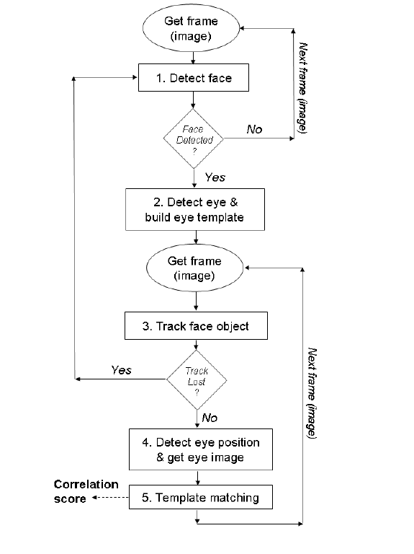

**Software Requirements**

* **PLATFORM**
* Python
* **LIBRARIES**
* OpenCV
* NumPy
* haarcascade_frontalface_default.xml

**Conclusion**

In this project, I will be trying to recognize faces in real time obtained from camera. I have used Haar feature-based cascade classifiers approach for face detection. It is a machine learning based approach where a cascade function is trained from a lot of positive and negative images. It is then used to detect objects in other images.

Several advantages of this algorithm are: Efficient feature selection, Scale and location invariant detector, instead of scaling the image itself, we scale the features Such a generic detection scheme can be trained for detection of other types of objects (e.g. cars, legs). It also has some disadvantages: Detector is most effective only on frontal images of faces, it can hardly cope with 45° face rotation both around the vertical and horizontal axis and Sensitive to lighting conditions

Future enhancement of project could be criminal identification, biometric security system, Image filter (snap filter) camera application, TV show identification from characters etc.

**References**

* <http://docs.opencv.org/trunk/d7/d8b/tutorial_py_face_detection.html>
* <http://opencv-python-tutroals.readthedocs.io/en/latest/index.html>
* <http://ieeexplore.ieee.org/document/7800424/>
* <https://www.cs.auckland.ac.nz/~m.rezaei/Downloads.html>

|  |
| --- |
|  |
|  |